**DAILY REPORT**

**Student Name :SINDHU.N**

**Class and Sec : VI B**

**USN :4AL17CS094**

**DATE:01-08-2020**

|  |  |  |  |  |
| --- | --- | --- | --- | --- |
| **Online Test Details** | | | | |
| **Subject** | ------ | | | |
| **Semester** | VI -B | | **Duration** | ----------- |
| **% of marks** | | ---- | | |

|  |  |  |  |
| --- | --- | --- | --- |
| **Certification Course Details** | | | |
| **Course** | Cyber Security | | |
| **Certificate Provider** | Great Learning | **Duration** | 5.5hours |

**Snapshots of the daily class acitivities .**

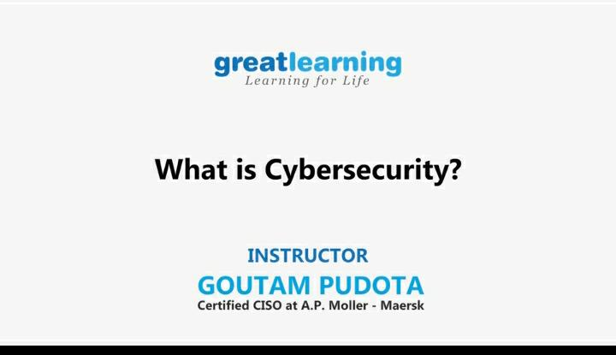

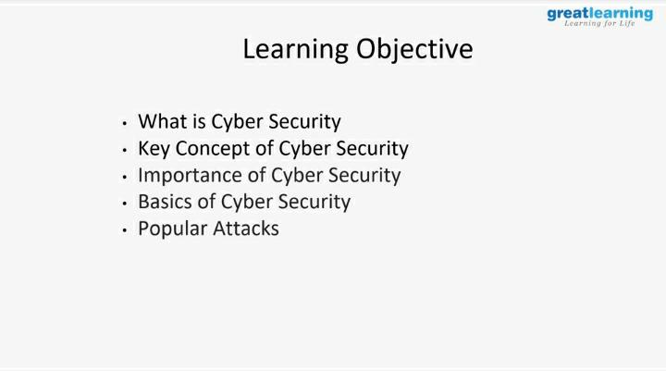

|  |  |
| --- | --- |
| **Coding Challenges** | |
| **Problem Statement:**  1.**Python Program for Find the perimeter of a cylinder.** | |
| **Status:** Executed | |
| **Uploaded the report both in Github & Slack** | Yes |

**Snapshots of your response to challenge.**

1. ****Python Program for Find the perimeter of a cylinder.****

**def perimeter( diameter, height ) :**

**return 2 * ( diameter + height )**

**diameter = 5 ;**

**height = 10 ;**

**print ("Perimeter = ",perimeter(diameter, height))**

****OUTPUT****

